Yuyi Zhang
Sep 20, 2020
Fall 2020 CPS Quarter
Instructor: Dr. Steward Huang
Module 1:
Classification Using Nearest Neighbors
ALY 6020_Predictive Analytics

Introduction
In this report, we are going to go through two cases using k-NN (k-mean Nearest Neighbors) to solve classification problems. In part A, we will work on the case of “diagnosing breast cancer with the k-NN algorithm” from our textbook “Machine Learning with R”. In part B, we are going to use “German credit dataset” that I found from dataset forum “Machine Learning Repository” to predict credit results using k-NN.

Analysis
In general, we split the entire dataset into training data and test data while applying k-NN algorithm. First, we are going train the k-NN model using training dataset. Second, test datasets using the previous model to get predict results. Then estimate the accuracy by comparing the predicted results and the actual test data.

Wisconsin Breast Cancer Diagnostic dataset

Step 1 – collecting data
The breast cancer dataset contains 569 rows of recodes with 32 variables. We are going to use 3 of the 30 measurement variables to investigate the diagnosis of “M” indicating “malignant”, or “B” indicating “benign”.

Step 2 – exploring and preparing the data
After importing the dataset, we take a look at the dataset using str() function.
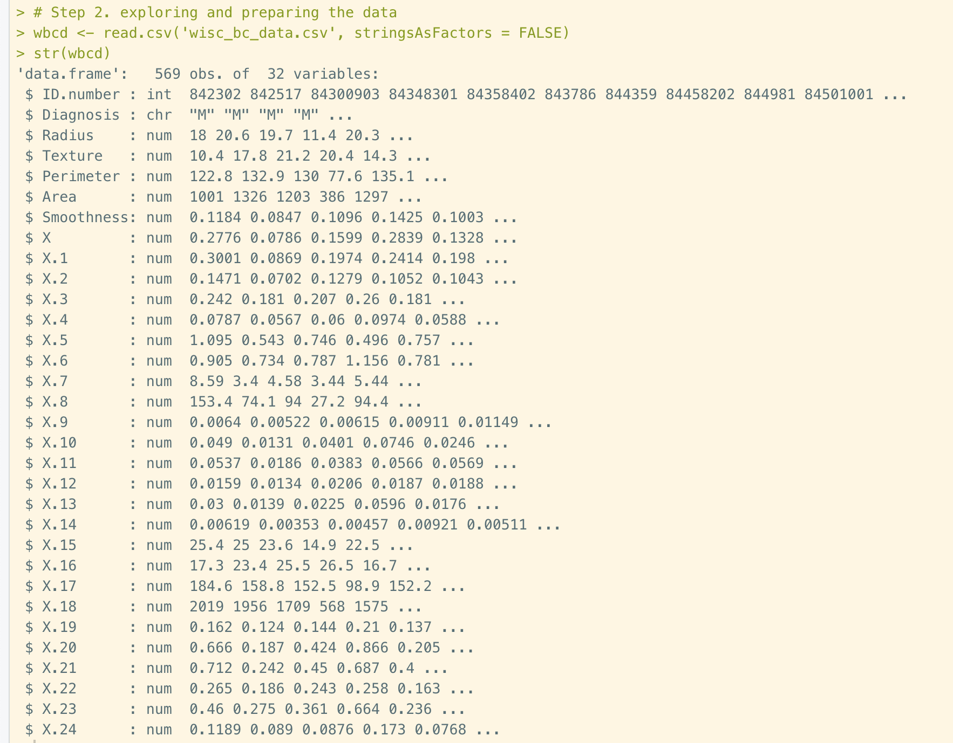
Figure 1. Importing data and structure
We could see that the first column is ID number, which provides zero help on our classification. So, we eliminate the them.
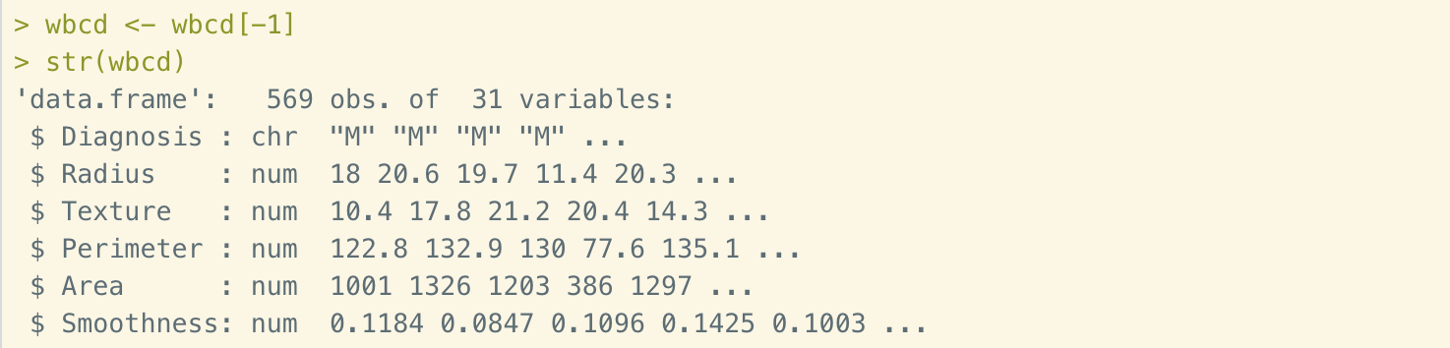
Figure 2. Excluding the ID column
Now there are 31 columns left in the dataset. The first column is the diagnosis. The machine learning classifiers require it to be a factor. So, we need to recode it and take look at the portion.
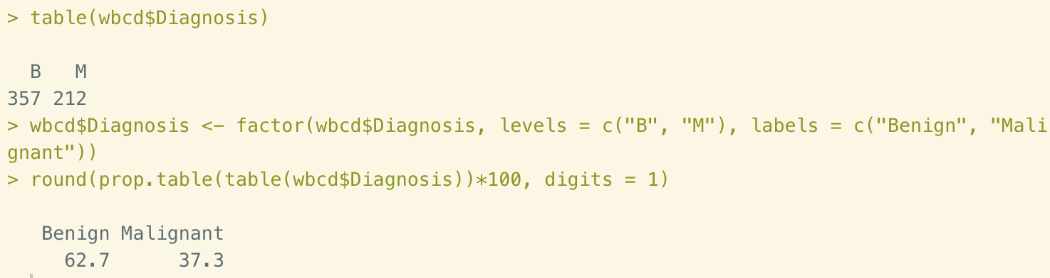
Figure 3. Recode the diagnosis column
Next, we are going to work on the numeric data. Take a first glance of the deciding variables, we could see that the Area ranges are much higher than Smoothness’s. This difference will impact the distance calculation, in turn, impact the accuracy of classification.
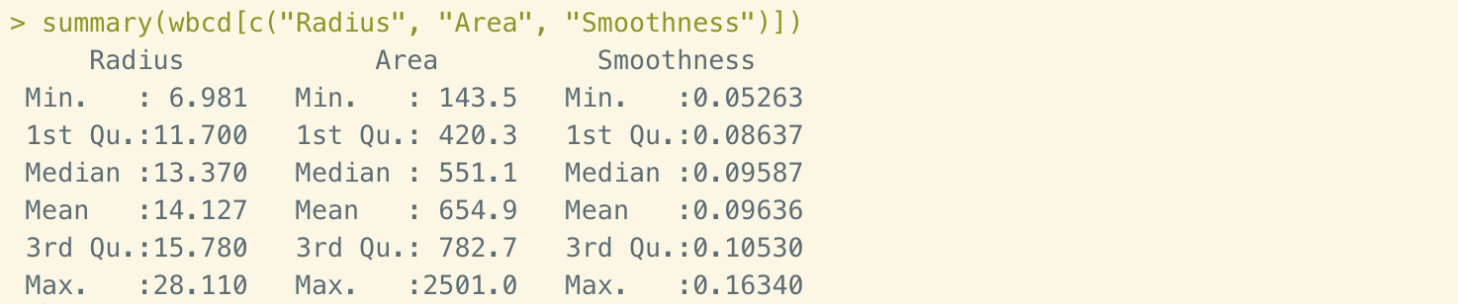
Figure 4. Three deciding variables
To solve the problems, we need to normalize the numeric data. In this case, we are going to build a normalize() function. Then transform all the numeric data in column 2 to 31 into range of 0 to 1.
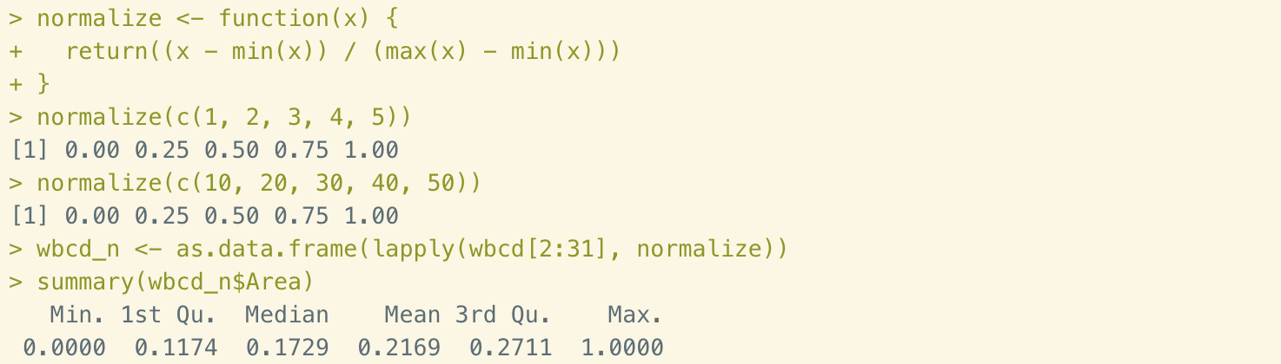
Figure 5. Transformation
The last action of data preparation is to create training and test datasets. In this section, we are going to split the original data into two parts: first 469 records for training purposes and last 100 records for testing. Then we store the class labels in factor vectors in column 1.
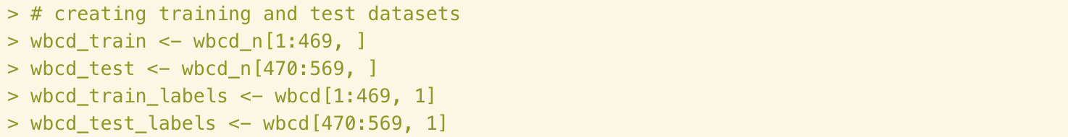
Figure 6. Split the dataset
Till now, all the data preparation work is done. In the next step, we are going to conduct training process to the first portion of the dataset.

Step 3 – training a model on the data
The knn() function in package ‘class’ provides the basic k-NN algorithm calculation solutions. It identifies instances in the test data using Euclidean distance. There are four parameters, which are train, test, class, and k. We’ve already got the first three parameters in the previous step. Now we need to work on k-value. K-value means the number of nearest neighbors. Usually we use square root of the data volumes. In this case, there are 469 instances in testing dataset, so the k-value is founded to 21.

Figure 7. Generate training model

Step 4 – evaluating model performance
Now it’s time to compare the predicted results and the actual testing values. To do this, we are going to use function CrossTable() in ‘grodels’ package. There are two parameters in this function. Then comparing results are showing as below:
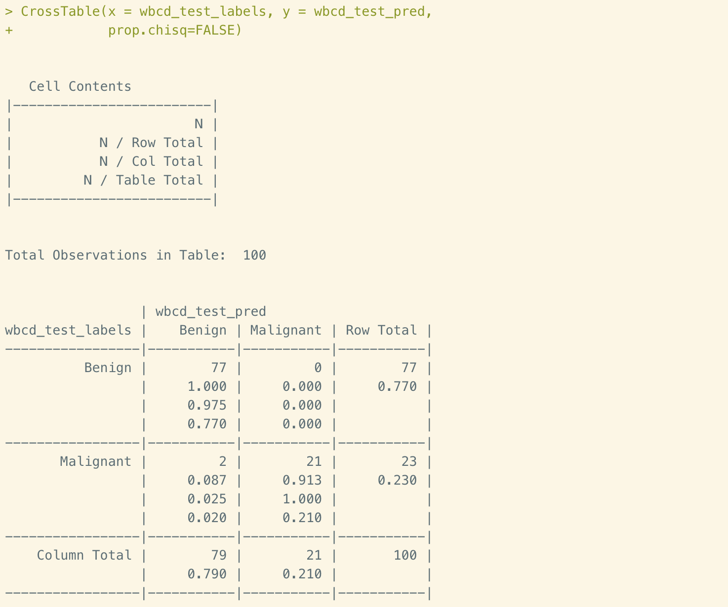
Figure 8. Evaluating model performance
In this table we could see that there are 2 cases in the bottom left cell showing that the predicted results disagreed with the actual test values. Those are all false negative results in this case. The Malignant values were miss predicted as Benign. This is the worse scenario than the false positive, which there is 0 cases in the top right cell.
In general, total 2 out of 100 cases were incorrectly predicted by the k-NN algorithm. The accuracy of 98% could be well accepted.

Step 5 – improving model performance
In this part, we are going to explore two more amendment. First, apply an alternative approach to standardize numeric variables. Second, try multiple other k-values.
First, we use z-score to rescale wbcd, and get the result as below.
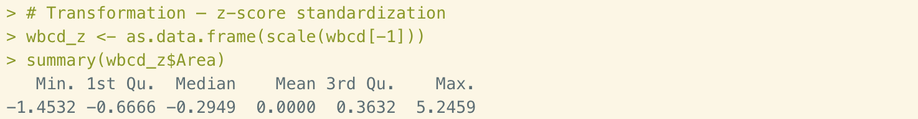
Figure 9. Z-score standardization
Then apply same process to apply k-NN algorithm. The evaluation table shown as below:
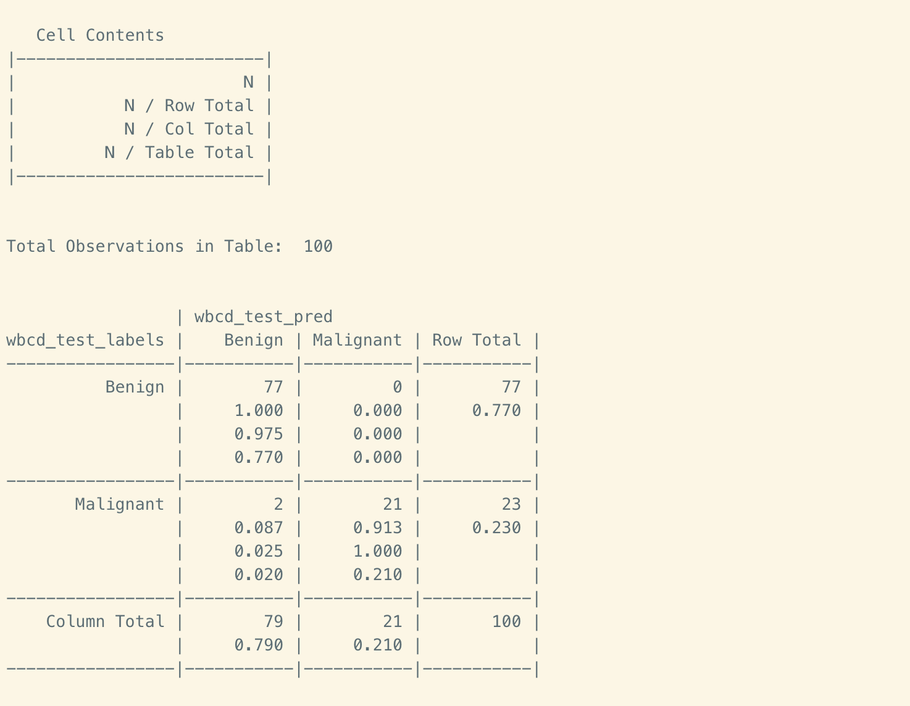
Figure 10. Modified performance result
As we could see that this result didn’t make any improvement as previously. It also contains 2 false negative cases in lower left cell. Therefore, we don’t accept this amendment in this dataset.
Second, manually try 5 more different k-values. The results are listed below:
k-value | False negatives | False positives | Percent classified incorrectly
1 | 2 | 4 | 6 percent
5 | 0 | 4 | 4 percent
11 | 1 | 1 | 2 percent
15 | 2 | 0 | 2 percent
21 | 2 | 0 | 2 percent
27 | 2 | 0 | 2 percent
Table 1. Multiple k-values attempt
In this case we could see from the table, the square root of the instance makes pretty good estimation of k-value. 98% of accuracy is impressive base on such a low volume of records.

German Credit dataset

Step 1 – collecting data
South German Credit dataset is an edited version of Statlog German credit data that released in November 2019. There are 1,000 records in this dataset with 20 variables. The updated version has transformed several indicator variables to numeric variables so it would be more suitable for k-NN algorithms, the one that doesn’t cope with categorical variables.

Step 2 – exploring and preparing the data
First, let’s take a quick look of the dataset.
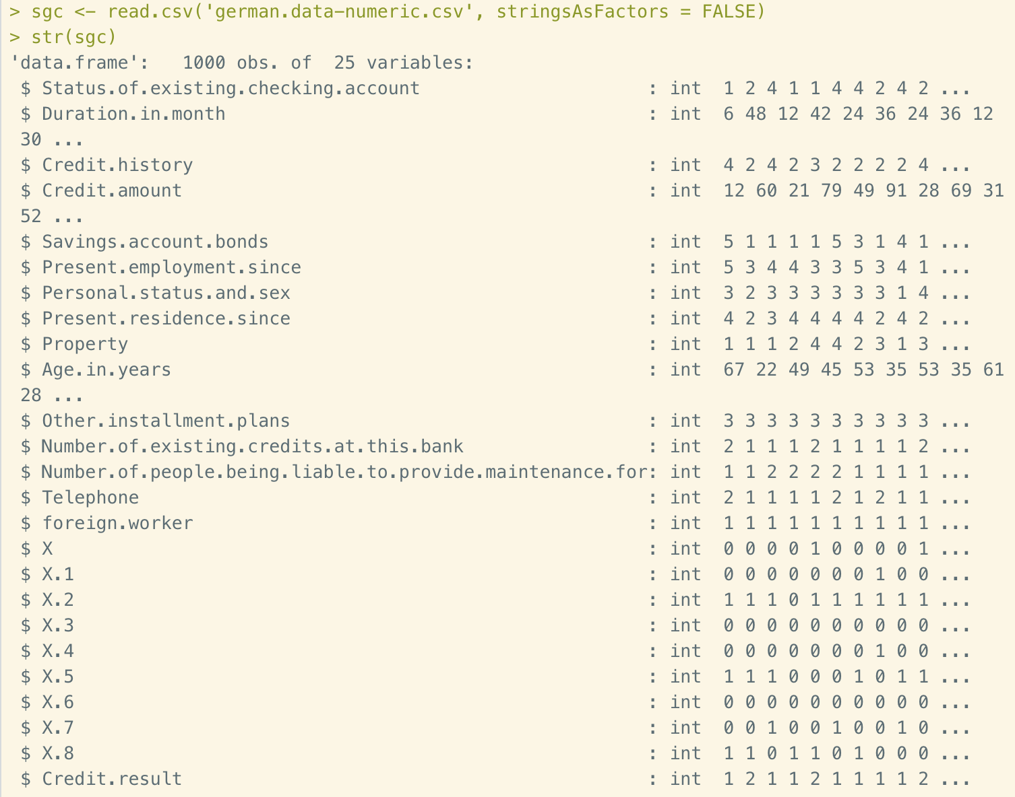
Figure 11. Importing South German Credit dataset
The diagnosis variable of this dataset is “good” or “bad” credit evaluation in the last column, (where 1 = good, 2 = bad). The rest of columns have been transformed to integer form. Recode the last column to factors.
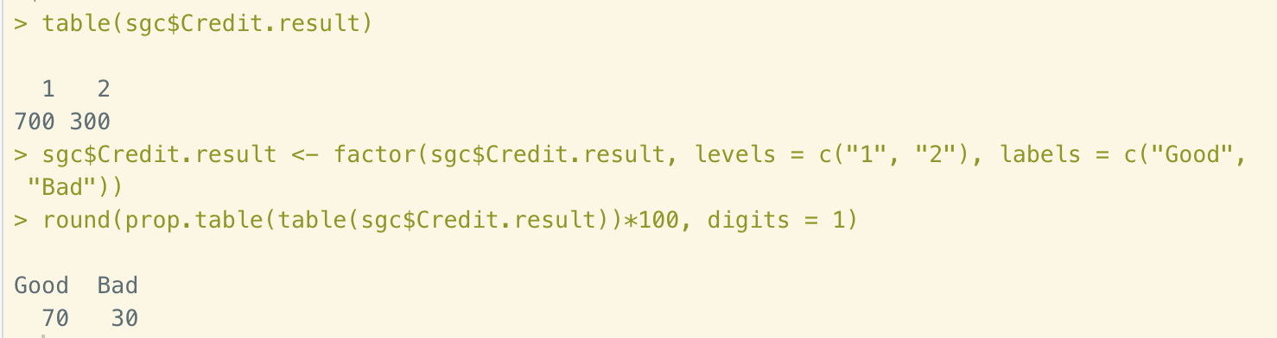
Figure 12. Recode diagnosis columns
Next, normalize the numeric data using normalize() function that we built in Part 1.
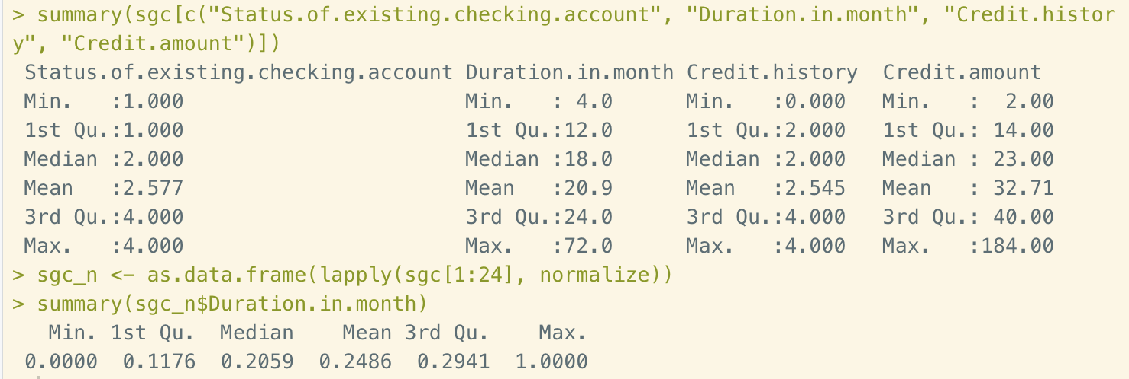
Figure 13. Normalizing numeric data
Last, divide the entire database into two parts, 800 records for training data and 200 records for test data. Then store the class labels in designated vectors.
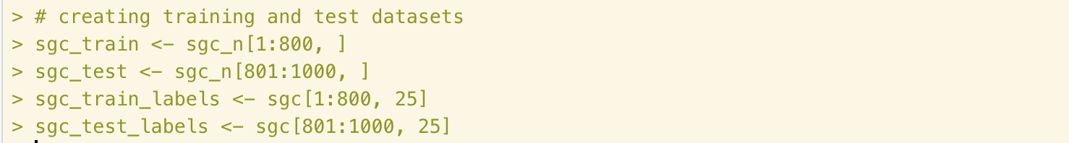
Figure 14. Split dataset

Step 3 – training a model on the data
All the preparation work is done in step 2. Now we are going to conduct k-NN algorithm modeling using knn() function. K-value is determined by the integer number of square root of the 1000, which is 28.
Figure 15. Training process

Step 4 – evaluating model performance
Process the comparing and evaluation section by using CrossTable() function.
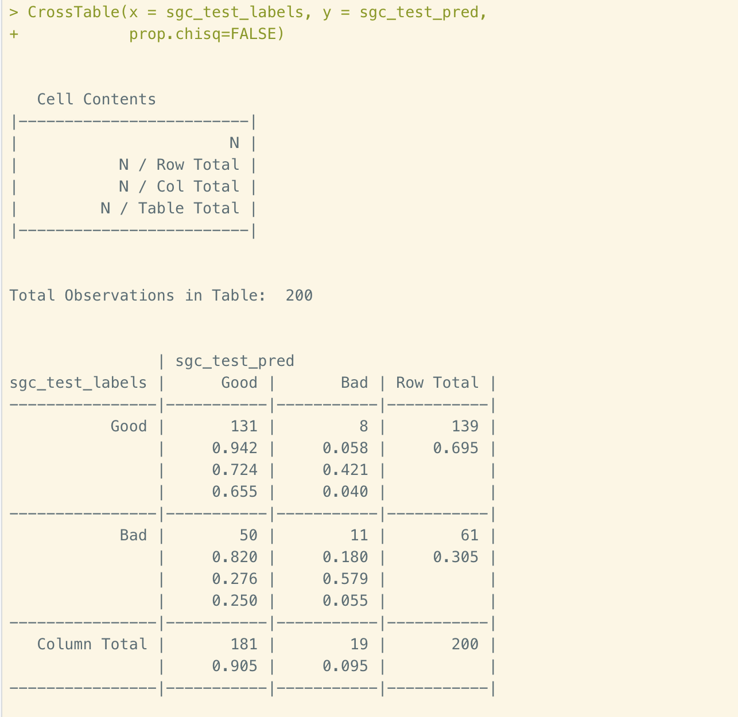
Figure 16. Performance evaluation
The results show that there are 50 false negatives and 8 false positives. The accuracy of this prediction is only 71%. Even worse, over 86% of the incorrect predictions are false negatives. So next step, we are going to perform two more improving attempts to see if the accuracy could be improved.

Step 5 – improving model performance
The first attempt is to apply z-score to rescale the numeric columns.
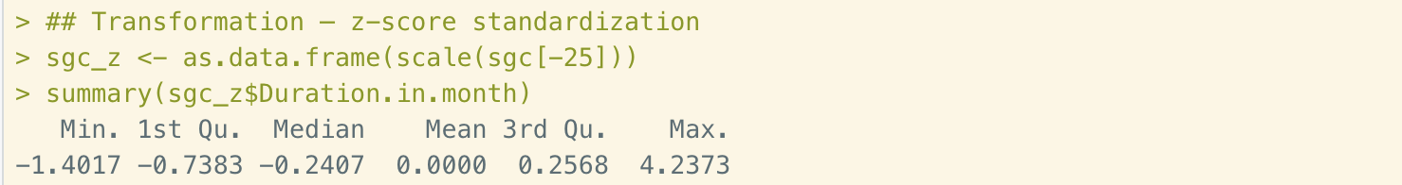
Figure 17. Z-score normalization
The process the same functions to evaluate the model.
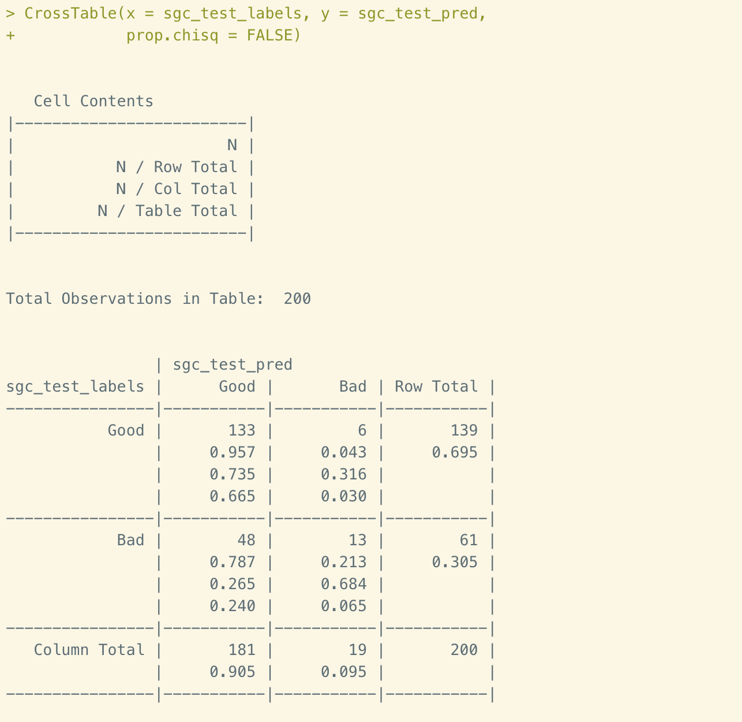
Figure 18. Evaluation performance table
With z-score normalization, we’ve got slightly improvement of 73% accuracy with less portion of negative positives. So, this amendment is accepted.
Now let’s try multiple alternative k-values. The results matrices shown as below:
k-value | False negatives | False positives | Percent classified incorrectly
1 | 37 | 32 | 34.5 percent
5 | 40 | 22 | 31 percent
10 | 42 | 15 | 28.5 percent
15 | 45 | 14 | 29.5 percent
20 | 47 | 10 | 28.5 percent
25 | 49 | 8 | 28.5 percent
30 | 47 | 8 | 27.5 percent
32 | 48 | 6 | 27 percent
35 | 50 | 5 | 27.5 percent
40 | 51 | 2 | 26.5 percent
45 | 54 | 2 | 28 percent
Table 2 Multiple k-values attempt
In this table we could see that the lowest incorrectly percent is 26.5 when k-value is 40. But in this scenario, we’ve got a higher false negative value of 50. As we mentioned earlier, false negatives are the worse cases than false positives. Therefore we purse the second lowest percent, which is 27, with a k-value of 32.

Conclusions
In this report, we apply k-NN algorithm to 2 sets of data. The first one is Breast Cancer Screening. The knn() function stores the training data and perform a classification process by calculating Euclidean distance of each data. In the end, we’ve got an impressive performance of 98% accuracy. But for the second case, unfortunately, the accuracy is under 75%. We’ve gone through z-score standardizing or multiple alternative k-values. The z-score provides better prediction. The k-value are best estimated by the square foot of the number of training examples.
k-NN doesn’t seem to be the best algorithm to analyze this dataset. I’ll try other algorithms later in this course to see if I could find the good one.

Reference
- Lantz, B. (July 2015). Chapter 3: Lazy Learning -Classification Using Nearest Neighbors. In Machine Learning with R (2nd ed., pp. 65-87). Birmingham, UK: Packt Publishing.
- Machine Learning Repository. (2020, June 20). South German Credit (UPDATE) Data Set [Data file]. Retrieved from http://archive.ics.uci.edu/ml/datasets/South+German+Credit+%28UPDATE%29

